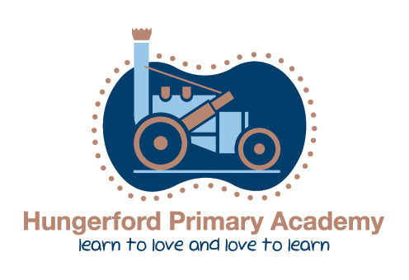

Art & Design Policy
Implementation Date: May 2025
Review Date: May 2026

Art & Design Lead: Miss S Jarvis

The Arts Policy
Introduction
This document is a description of our current practice and procedures in the teaching of The Arts. The elements which make up this area of the curriculum encompass the discrete teaching of Literature, Performing Arts, Visual Art crafts and design, Media, Multimedia and Music. In the Foundation Stage our teaching of The Arts enters the Statutory frame work for early years foundation stage 2021 and Development Matters 2021; focusing on areas of Expressive Arts and Design, Physical development, Personal, Social and Emotional Development and Communication and Language. This policy also refers to our practice of cross-curricular teaching and learning which encourages children to make links and practise skills in a relevant and interesting way.
Our belief is that all individual learning styles should be recognised and honoured in a creative learning environment. The way in which we learn is as important to progress, success and wellbeing as what we learn.
The following policy reflects the consensus of opinion of the teaching staff and has the support of the Governing body. It is updated by means of an annual review, when aims are set for the following year.
Art intention
At Hungerford, we believe that the Art curriculum stimulates creativity in all learners and inspires them to express themselves though a variety of Medias. Children will learn and practise a range of skills in order to give them the opportunities to develop their own artistic styles. They will learn about successful artists both historical and current; to enable them to see how art skills learnt in school can be used to produce works which can have a large impact on society. Our Hungerford children will also have opportunities to work with and see local artists as well as visit local galleries and art exhibitions. Our Curriculum cultivates well-being and aids young learners to have meaningful artistic experience; having the understanding that art is a process not a product. Where art is concerned at Hungerford, it is a process of creating, exploring, discovering and experimenting.
The aims of the arts curriculum are:

- Encouraging expression
- Giving children ‘a voice’
- An opportunity to interpret and influence the world around us
- Having pride in what we do and appreciating the efforts of others
- Taking joy in aesthetics
- Owning our environment and giving pleasure to others
- Is it truly creative? (we don’t aim to produce 30 identical pieces of work; skills and techniques may be focussed upon, but that which is created is not intended to be identical)
- Pursuing freedom, creativity, success at one’s own level, exploration, finding understanding and meaning, appreciation, learning to be part of an audience
- Skills and understanding: process rather than just end product
- No right and wrong way, no right or wrong answer
- Expressing personal feelings through their art, craft and design work
Implementation of the Arts curriculum

The National Curriculum has no definition of what the minimum entitlement should be for The Arts curriculum, other than that all pupils should have the opportunity to pursue the aims of the subject, through the way they engage with the programme content. At Hungerford we believe pupils are entitled to a broad and balanced curriculum in The Arts which allows for progression of skills and individual responses.
At Hungerford we use Arts progression objectives for each year group from EYFS-Y6. These are clear objectives broken down into small steps in order for the children to have the opportunities to acquire a wide range of skills. These objectives have been formed from The Department of Education document, ‘Art and Design programmes of study 2013)’.
Foundation Stage
Teaching and learning Arts follows the guidance set out in the Early Years Foundation Stage documentation ‘Development Matters’. Expressive Arts and design is the focus area of learning and has two aspects: Exploring and using Media and Materials and Being Imaginative. The children have opportunities to participate in both adult led and child initiated activities to experiment with colours, materials, textures and design as well as learning to use basic tools such as: scissors, paint brushes, glue sticks and printing sponges.

Key Stage One and Two
In Key Stage One and Two Art is taught in projects either every week or in blocks; ensuring that a project is completed every term in order for the children to access the full curriculum coverage of their year group. Where possible, cross curricular links should be made to provide meaningful links with other foundation subjects to help put learning into context. To enhance the learning experience of our children, our Art curriculum:
- Uses metacognition strategies (e.g. Mood boards) to ensure knowledge is being refreshed, reflected on and used well.
- Provides age appropriate Artistic vocabulary that is used and modelled by staff.
- Uses high quality resources- tools, materials. In order for children to learn and practise skills effectively.
- Uses a wide range of artists; both historical and current to show how art has impacted the world and to compare similarities and differences through time.
- enriching opportunities for children to understand how art is created in the local area by experiencing original art work through visits to art galleries or work with practising artists, craft makers or designers.
- Aims to make productive Links with local galleries, creative practitioners and industries that enables pupils to appreciate the uniqueness of their environment.
- Uses Sketchbooks as part of the creative process. This should contain sketches, doodles, soft drawing, notes, material samples etc., to aid the progression throughout the children’s projects.
- Allows children to take ownership of the presentation of their work; organising their sketchbooks and final pieces purposefully highlighting the skills they have used.
- Purposeful and exciting reading, writing and maths opportunities are presented to children to apply their learning across the project.
- Ensures the progression of skills between year groups advances appropriately throughout the year groups to ensure knowledge is built upon. This, allowing teachers to identify gaps in learning and highlight areas for further progression.
- Makes an outstanding contribution to pupils’ spiritual, moral, social and cultural development.
- Enables children to work independently, creatively and collaboratively.
Presentation
The presentation of art pieces is an important aspect to highlight the skills the children have learnt and decided to incorporate within their art and design learning journey. Sketchbooks should have the WALT at the top of the sketchbook page when a new progressive objective has been taught this will be in form of a question. The Date and child’s signature should be at the bottom of the sketchbook page. This is to give children ownership of their work and also to contextualise their work into the real world; as professional artists would sign and date their art pieces. Please refer to example below.
What are the different ways I can create lines of different thickness?
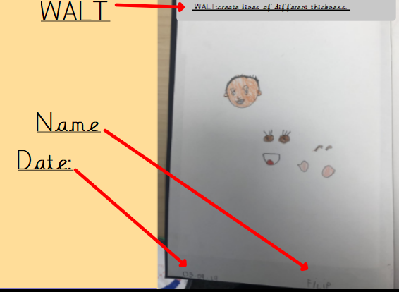

At the start of a new project a mood board should be stuck into the sketchbooks. This aids the artistic process throughout their projects to ensure children can reflect on what they have learnt in lessons immediately. In addition, it is also used to refer back to throughout the year in order to develop, improve and master art skills. Please see example of mood boards below.
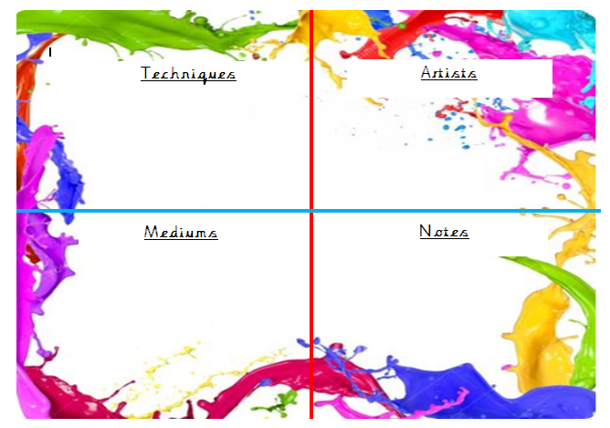
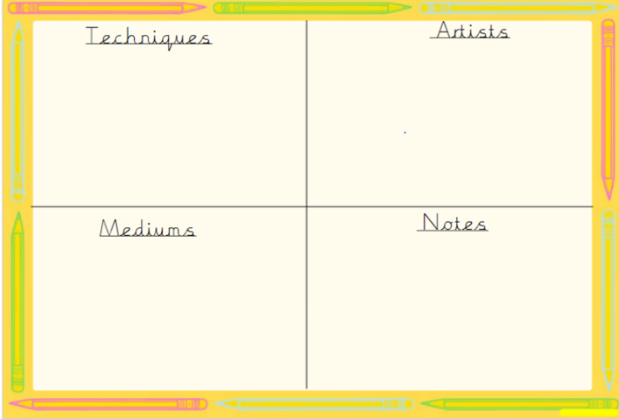

The presentation of the children’s work within their sketchbook encourages purposeful drawings, annotations and experimentations with colour and a variety of materials. Although children may be focusing on the same skill it is always evident that each child’s work is unique and represents their thought process alone. Sketchbooks are used as an aid within their learning process in order to create their final pieces.
The Sketchbook process has a great emphasis on teaching the key skills before creating their final products. Please see example below for further guidance.
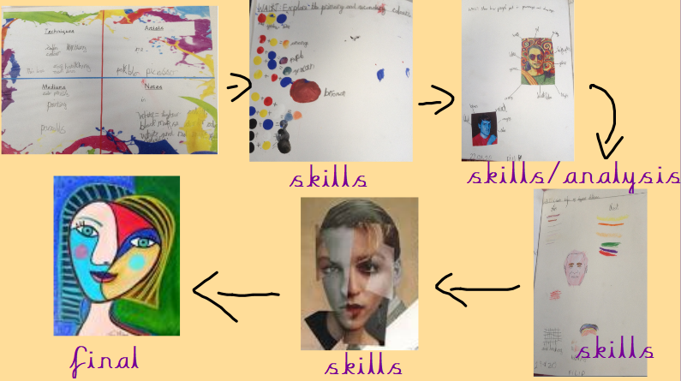

Assessment and recording

At Hungerford we access children’s work in Art by making informal judgements as we observe each lesson. At the beginning of each project we talk about the skills we already know to retrieve the children’s prior learning. At the end of each project, each child has a final piece that they have created based on the skills that have been taught that term. Teachers make informal judgements on this also and consider how the skills are used. Sketchbooks are also monitored by teachers to see the children’s reflected process which is also evident in conversations between adults and peers in KS1 and in addition; in sketchbook annotations in KS2.
Y1-Y6 children will record their sketchbook works and physical art pieces on their Showbie accounts. This will clearly indicate the progression of skills and sequence of lessons for the unit coverage for the term.

Computing

The arts curriculum enables pupils to use the internet to research artists, styles and techniques. It also provides opportunities for children to present their work or information using media software and art based programs. This includes children taking pictures or videos which can also be used to explore, annotate and reflect on particular art pieces in more detail.

Inclusion and Equal Opportunities

All pupils are valued and teaching is targeted to meet the needs of individual learners. Those children identified as requiring extra assistance are afforded additional opportunities to further develop their skills through interventions provided by staff. This applies to both the More Able and Greater Depth, and children with special educational needs. Every child, regardless of ability, gender, ethnicity, class, culture, experiences and background will be supported to be successful within this area of learning.
At Hungerford Primary Academy, we provide equality of opportunity. For us, inclusive education means the greatest degree of match or fit between the individual learner’s requirements and the provision that is made for him or her. At the heart of our thinking is the belief that children should be actively included and fully engaged in their learning.

We see the school as a working community, which respects not only diversity of appearance but that of opinions, beliefs, practices, ideas and abilities. We endeavour always to represent an inclusive school family.

Related Documents
Inclusion Policy
Assessment Policy
Pupil Premium policy
Safeguarding Policy and Child Protection Policy

