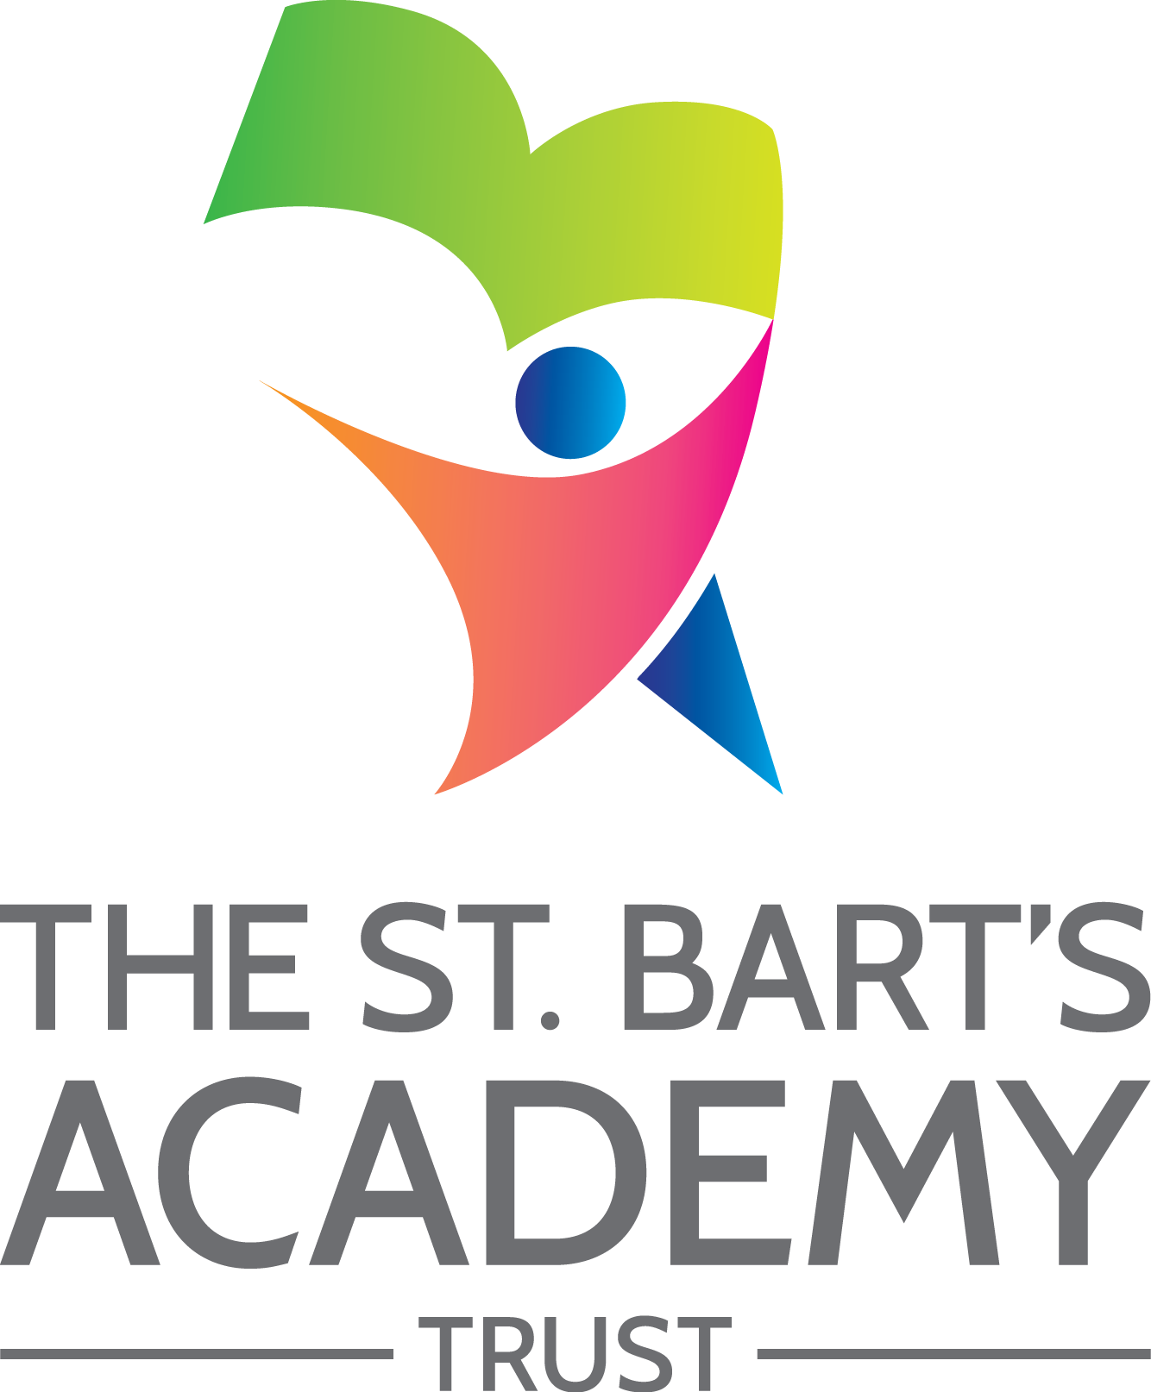

Hungerford Primary Academy

Accessibility
Plan

December 2024

The St. Bart’s Academy Trust
Accessibility Plan
Date | Section Amended | Signature
01/03/2023 | TSB Policy Adopted – v4 | S. Jones

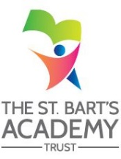

Contents

Statement of intent 4
1. Accessibility Plan - 2022-2023 5
2. Planning Duty 1: Curriculum 6
3. Planning Duty 2: Physical Environment 7
4. Planning Duty 3: Information 8

Statement of intent
This plan outlines how Hungerford Primary Academy aims to increase access to education for pupils with disabilities in the three areas required by the planning duties in the Equality Act 2010 (i.e. the curriculum, physical environment and information).
A person is regarded as having a disability under the Equality Act where they have a physical or mental impairment that has a substantial and long-term adverse effect on their ability to carry out normal day-to-day activities.
This plan aims to:
- Increase the extent to which pupils with disabilities can participate in the curriculum.
- Improve the physical environment of the school to enable pupils with disabilities to take better advantage of education, benefits, facilities and services provided.
- Improve the availability of accessible information to pupils with disabilities.
The above aims will be delivered within a reasonable timeframe, and in ways which are determined after taking into account pupils’ disabilities and the views of parents and pupils. In the preparation of an accessibility strategy, the LA will have regard to the need to allocate adequate resources in the implementation of this strategy.
The governing committee also recognises its responsibilities towards employees with disabilities and will:
- Monitor recruitment procedures to ensure that individuals with disabilities are provided with equal opportunities.
- Provide appropriate support and provision for employees with disabilities to ensure that they can carry out their work effectively without barriers.
- Undertake reasonable adjustments to enable staff to access the workplace.
- The plan will be resourced, implemented, reviewed and revised in consultation with:
- Pupils’ parents.
- The principal and other relevant members of staff.
- Governors.
- External partners.

- Accessibility Plan - 2024-2025
Our Accessibility Plan sets out how this Academy will improve equality of opportunity for disabled people. This plan sets out the establishment’s proposals to increase access to education for disabled pupils in the following three areas:
- Increasing the extent to which disabled pupils can participate in the curriculum on an equal basis with their peers;
- Improving the physical environment of the establishment to enable disabled pupils to take better advantage of education and associated facilities and services; and
- Improving the availability of accessible information to disabled pupils.
The preparation of the Accessibility Plan has been informed by audits and analyses of data within the Academy and its premises. It is a requirement that the Accessibility Plan is resourced, implemented and reviewed as necessary and at least annually. A copy of this Plan together with the SBMAT Accessibility Policy will be placed upon our website.
This plan will be reviewed on an annual basis by the Local Governing Committee and Principal. Any changes to this plan will be communicated to all staff members and relevant stakeholders.

- Planning Duty 1: Curriculum
Issue / Action | Lead Responsible | Identified Budget  and any other resources | Target Date | Success Criteria
To ensure that all middle leaders understand the EEF’s 5 a day SEN recommendations and how this will look in their subject | Subject leaders | Subject leadership time | Summer 2025 | All staff will be aware of the appropriate adaptations required for SEN Learners to meet their potential

- Planning Duty 2: Physical Environment
Issue / Action | Lead Responsible | Identified Budget  and any other resources | Target Date | Success Criteria
As per the DDA, the wall that any toilet is on, needs to be a different colour to the other walls in order to support VI | Anna Wheaver/ Drew Salmon | TBC | Summer 2025 | All toilets will have a wall painted a different colour to support VI children/adults

- Planning Duty 3: Information
Issue / Action | Lead Responsible | Identified Budget  and any other resources | Target Date | Success Criteria
Children with sensory impairments are supported in a timely manner with appropriate provision in place according to the SI team. | SENCO | N/A | Spring 2025 | All HI and VI pupils will have full and appropriate access to all aspects of their school day.
Parents with limited literacy skills are not always able to access information in an equitable manner. | Teaching Staff | N/A | Ongoing | All parents will feel confident in knowing all shared information.

St. Bart’s Multi-Academy Trust
c/o Belgrave St. Bartholomew’s Academy,
Sussex Place, Longton, Stoke-on-Trent, Staffordshire, ST3 4TP
www.sbmat.org T: 01782 486350

