

MOBILE PHONE

POLICY

February

202
6

Details
Title: | Mobile Phone Policy
Issued: | February 2026
Next Review: | February 2029
Owner: | Ricky Porter
Category: | Operational
Date | Section Amended | Signature
Feb-26 | New Policy | R. Porter

Contents

St. Bart’s Mission 4
St. Bart’s Vision and Values 4
Mobile Phone Policy 5
1. Introduction and aims 5
1.1. Rationale and National Context: 5
2. Roles and responsibilities 6
2.1. Staff 6
2.2. Parents/Carers 6
2.3. Pupils 6
3. Use of mobile phones by staff 6
3.1. Personal mobile phones 6
3.2. Work phones 7
4. Use of mobile phones by pupils 7
5. Sanctions 7
6. Use of mobile phones by parents, volunteers and visitors 8
7. Loss, theft or damage 9
8. Monitoring and review 9
Appendix 1 – Academy Information 10
Appendix 2 – Mobile Phone Permission Form 11

Flourishing Together
Releasing Potential
Inspiring Futures

St. Bart’s Mission
We ensure that every academy is a flourishing community, dedicated to releasing potential and inspiring ambitious futures through exceptional education.

St. Bart’s Vision and Values
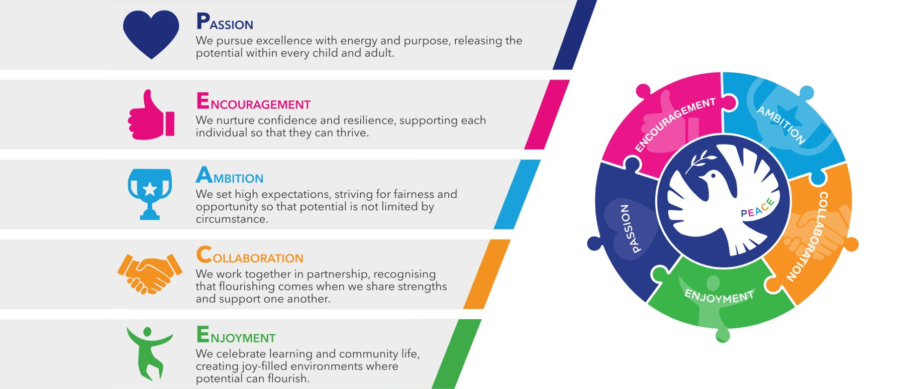
Releasing potential together through PEACE:

Our Trust Christian ethos is captured by the PEACE values and all schools work in close partnership (whether C of E or community) to ensure that all children, adults and the communities they serve flourish just as Jesus encouraged us to do in John 10:10 – “I have come that they may have life, and have it to the full.”

St. Bart’s vision includes a strong commitment to preparing our children for a world impacted by climate change, through learning and practical experience. We encourage pupils and staff to consider the impact of their actions locally and globally, while embedding climate change education across our curriculum, and sustainability into our ethos and Trust-wide practice.

Mobile Phone Policy

Introduction and aims
St Bart’s Multi Academy Trust recognises that mobile phones are an important part of everyday life.
However, consistent with updated DfE guidance issued in January 2026, our academy operates a mobile phone-free environment throughout the entire school day, with use, visibility, or audibility of phones prohibited at all times on site.
For the purposes of this policy, 'mobile phone' includes smartphones, smartwatches with connectivity features (internet, messaging, camera), and any other internet-enabled personal devices.
This policy aims to:
- Maintain a calm, safe, disruption-free learning environment
- Protect pupils from online harm, bullying and safeguarding risks
- Set clear rules and expectations for pupils, staff, parents and visitors
- Clarify how exceptions, sanctions and confiscation procedures operate

This policy also aims to address some of the challenges posed by mobile phones in school, such as:
- Risks to child protection
- Data protection issues
- Potential for lesson disruption
- Risk of theft, loss, or damage
- Appropriate use of technology in the classroom

Rationale and National Context:
The Department for Education states that:
- All schools should be mobile phone-free environments by default; anything else should be by exception only
- The ban must apply throughout the school day, including lessons, transitions, breaktimes and lunchtimes
- Schools must enforce policies consistently and apply appropriate sanctions, including confiscation
- Ofsted will review the consistency and effectiveness of phone policies in every inspection from April 2026

Roles and responsibilities

Staff
All staff are responsible for enforcing this policy consistently and reporting misuse immediately. Staff must not use personal mobile phones in the presence of pupils except for essential, pre-authorised reasons listed in the Staff Code of Conduct.

Parents/Carers
Parents should support the academy’s mobile phone-free environment. Communication should be via the academy office if a parent needs to get in touch with their child

Pupils
Pupils must always follow the academy’s mobile phone expectations and comply with staff instructions.

Use of mobile phones by staff

Personal mobile phones
Staff (including volunteers, contractors and anyone else otherwise engaged by the school) are not permitted to use their personal mobile phone while children are present. Use of personal mobile phones must be restricted to non-contact time, and to areas of the school where pupils are not present (such as the staffroom).
There may be circumstances in which it is appropriate for a member of staff to have use of their mobile phone during contact time for personal reasons. For instance (this list is non-exhaustive):
- For emergency contact by their child, or their child’s school
- In the case of acutely ill dependents or family members
- To use multi-factor authentication
- Emergency evacuations
- Supervising off-site trips
- Supervising residential visits
- Conduct welfare checks off-site

In these circumstances, staff will:
- Use their mobile phones in an appropriate and professional manner, in line with our staff Code of Conduct.
- Not use their mobile phones to take photographs or recordings of pupils, their work, or anything else which could identify a pupil.

The Principal will decide on a case-by-case basis whether to allow use for special arrangements. However, if possible and if special arrangements are not deemed necessary, staff can use the academy office number as a point of emergency contact.

Work phones
Some members of staff are provided with a mobile phone by the academy for work purposes.
Only authorised staff are permitted to use academy mobile phones, and access to the mobile phone must not be provided to anyone without authorisation.
Staff must:
- Only use mobile phone functions for work purposes, including making/receiving calls, sending/receiving emails or other communications, or using the internet
- Ensure that communication or conduct linked to the device is appropriate and professional at all times, in line with our staff code of conduct.

Use of mobile phones by pupils
In line with the DfE guidance, pupils should not use their mobile phones during the school day, including during lessons, in the time between lessons, at breaktimes and at lunchtimes.
For Academy specific information please see completed Appendix 1.
In line with DfE requirements to make reasonable adjustments for pupils with disabilities, medical needs, or exceptional personal circumstances. Parents may apply for permission for their child to access or carry a mobile phone for:
- medical monitoring (e.g., diabetes apps)
- emergency health needs
- young carer responsibilities
- specific safeguarding reasons

Permission must be agreed by the Principal and recorded using the Permission Form for Special Circumstances (Appendix 2). Misuse of a permitted device will result in the permission being reviewed or withdrawn.

Sanctions
This policy should be read in conjunction with the DfE's statutory guidance 'Searching, Screening and Confiscation: Advice for Schools'. In line with DfE expectations that schools apply clear and appropriate sanctions, including confiscation, where policies are breached, our academy will take the following approach:
For Academy specific information please see completed Appendix 1.
In each case, the sanction given must be reasonable and proportionate. The Academy will also consider whether:
- There are any relevant special circumstances (for example, age, religious requirements, special educational needs, disability)
- The pupil’s behaviour may indicate they may be suffering, or at risk of, harm. If this is suspected, staff will follow the appropriate procedure set out in Part 1 of Keeping Children Safe in Education

Certain types of conduct, bullying or harassment can be classified as criminal conduct. The academy takes such conduct extremely seriously and will involve the police or other agencies as appropriate.
Such conduct includes, but is not limited to:
- Sexting (consensual and non-consensual sharing nude or semi-nude images or videos)
- Upskirting
- Threats of violence or assault
- Abusive calls, emails, social media posts or texts directed at someone on the basis of someone’s ethnicity, religious beliefs or sexual orientation

Use of mobile phones by parents, volunteers and visitors
Parents, visitors and volunteers (including governors and contractors) must adhere to this policy when visiting the site during the school day. This means:
- Mobile phones must be on silent when in classes
- Not taking pictures or recordings of pupils, unless permission has been received from other parents, or of their own child
- Not posting pictures / recording on social media without consent
- Not using mobile phones in lessons, or when working with pupils

Parents, visitors and volunteers are asked to only use mobile phones in designated areas (e.g. meeting rooms).
Parents or volunteers supervising school trips or residential visits must not:
- Take photos or recordings of pupils, their work or anything else which could identify a pupil.
Parents or volunteers supervising trips are also responsible for enforcing the academy’s policy for pupils using their mobile phones, as set out above, but must refer any sanctions to a member of staff, as they do not have the power to search or confiscate devices.
Parents must use the academy office as the first point of contact if they need to get in touch with their child during the school day.

Loss, theft or damage
The academy accepts no responsibility for mobile phones that are lost, damaged or stolen on school premises or transport, during visits or trips, or while pupils are travelling to and from school.

Monitoring and review
The academy is committed to ensuring that this policy has a positive impact of pupils’ education, behaviour and welfare. When reviewing the policy, the academy will take into account:
- Relevant feedback
- Records of behaviour and safeguarding incidents
- Relevant advice from the Department for Education, the Local Authority, St Bart’s MAT, or other relevant organisations

The Principal is responsible for implementing and monitoring this policy. It will be reviewed and approved every 3 years or earlier if national guidance changes.



ST. BART’S MULTI-ACADEMY TRUST
Mobile Phone Policy
Academy Specific Information

This appendix must be completed by each academy
It should be maintained and reviewed in line with the overarching Mobile Phone Policy.

Academy: | Hungerford Primary Academy

SECTION 4 – USE OF MOBILE PHONES BY PUPILS
Academy procedure:
Permission Required:
Pupils may only bring a mobile phone to school if a parental permission slip has been completed. The form must state the reason the phone is needed (e.g., walking home, travelling between parents' homes, split-family arrangements).
Handing In Phones:
Upon arrival, pupils must keep their phone in their bag, go straight to the school office, and hand it in.
All phones must be switched off before entering school.
Storage During the Day:
Phones will be securely stored in secure boxes in the office and can be collected at the end of the school day. Pupils must place their phone straight into their bag after collecting it.
Use on School Premises:
Phones must not be used or visible anywhere on school premises. They must remain switched off until the pupil has left the school grounds.

SECTION 5 – SANCTIONS
Academy approach:
First Breach:
If a pupil does not follow the mobile phone rules, they will meet with a member of the Principal/SLT team. The expectations and reasons behind the rules will be explained, and a verbal warning will be given.
This incident will be recorded on CPOMS.
Second Breach:
If the rules are broken again, the pupil will lose the privilege of bringing a mobile phone to school. The school will withdraw consent, and parents/carers will be contacted to collect the phone from the main office

Appendix 2 – Mobile Phone Permission Form
ST. BART’S MULTI-ACADEMY TRUST

Mobile Phone Permission Form
For special circumstances

PUPIL DETAILS
Pupil name:
Year group/class:
Parent/carer(s) name(s):

The school has agreed to allow the pupil named above to bring their mobile phone to school as they may:
- Need the phone to support their medical needs
- Walking home (only if permission been given)
- Attend a before- or after-school activity where a mobile phone is required for the activity, or to contact parents/carers
- Are a young carer

Pupils who bring a mobile phone to school must abide by the academy’s policy on the use of mobile phones
The academy reserves the right to revoke permission if a pupil does not abide by the policy.

Parent/carer signature:
Pupil signature
(where appropriate):

FOR SCHOOL USE ONLY
Authorised by:
Date:



